CMPSC 462 – In-class Assignment-7 (30 points)
Linked Lists – Singly and Doubly

Due date: 11/08/2022

Note: attach screenshots of your program and results under each programming exercises. Please make sure that the screenshot is readable. Don’t attach a very small screenshot image.

Exercise-1: 15 points
Develop a node class and a singly list class. The node class should have two state variables namely data and nextNode. The singly list class should contain the following methods:
- MiddleInsert – insert a node somewhere in the middle of the list
- StartInsert – insert a node at start of the Linked list
- EndInsert – insert a node at the end of the Linked list
- Delete – delete a node
- Traverse – prints all the node’s data
- Reverse – reverses the linked list
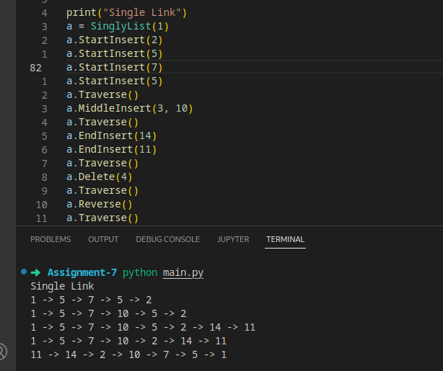

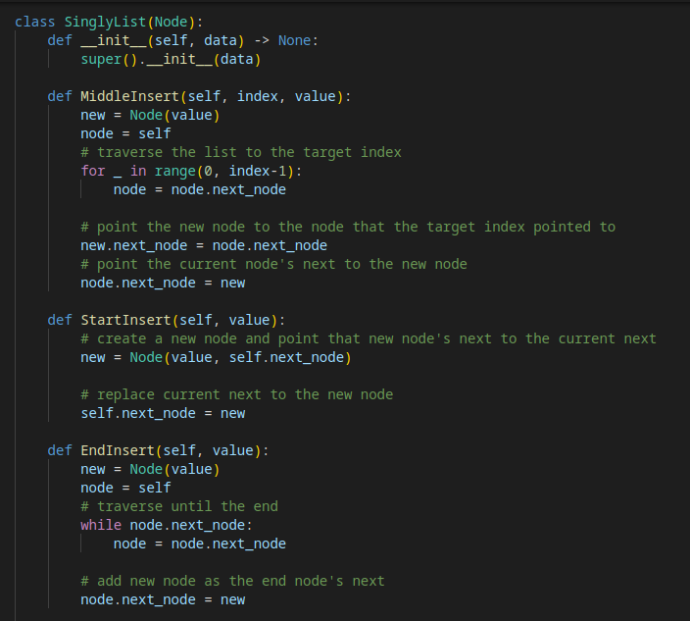

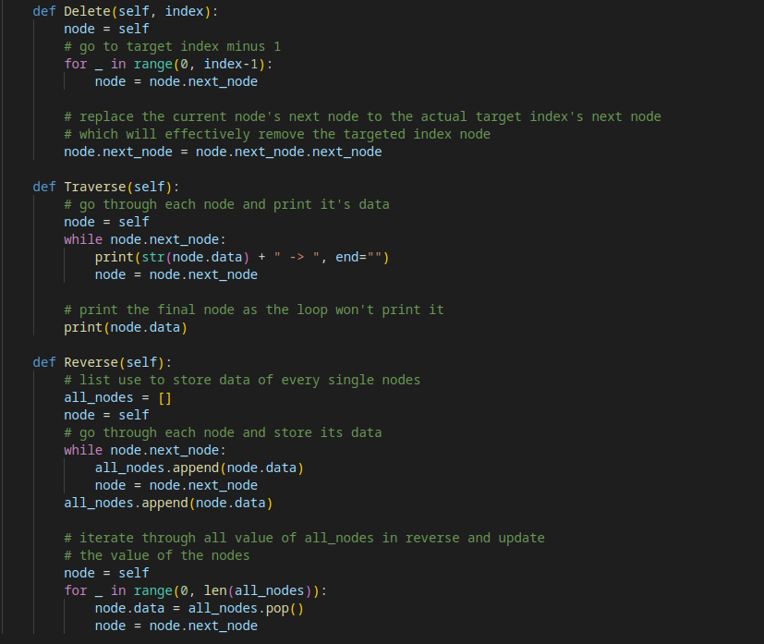
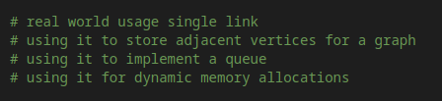

List out 3 real time usage of Linked List as comments in the program.
Note:
- Choose appropriate inputs for the above functions
- You can refer any source but try to follow the algorithm described in the lecture video
- Write the algorithm for each function as comments in the program
- Test the class’s function with an example.
- Attach screenshots of the program and results

Exercise-2: 15 points
Develop a node class and a doubly list class. The node class should have three state variables namely data, prevNode and nextNode. The doubly list class should contain the following methods:
- MiddleInsert – insert a node somewhere in the middle of the list
- StartInsert – insert a node at start of the Linked list
- EndInsert – insert a node at the end of the Linked list
- Delete – delete a node
- Traverse – prints all the node’s data
- Reverse – reverses the linked list

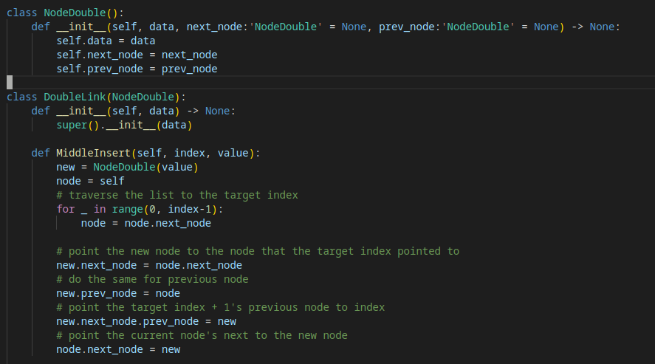

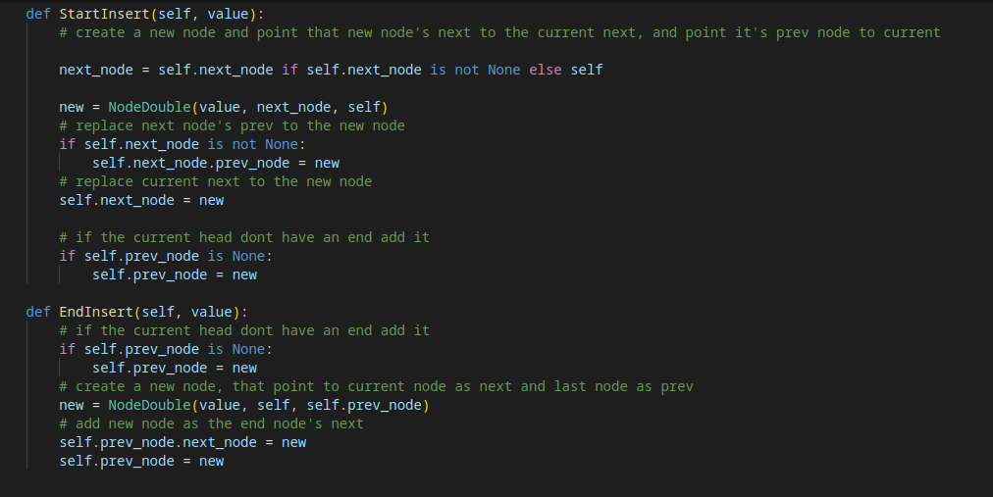
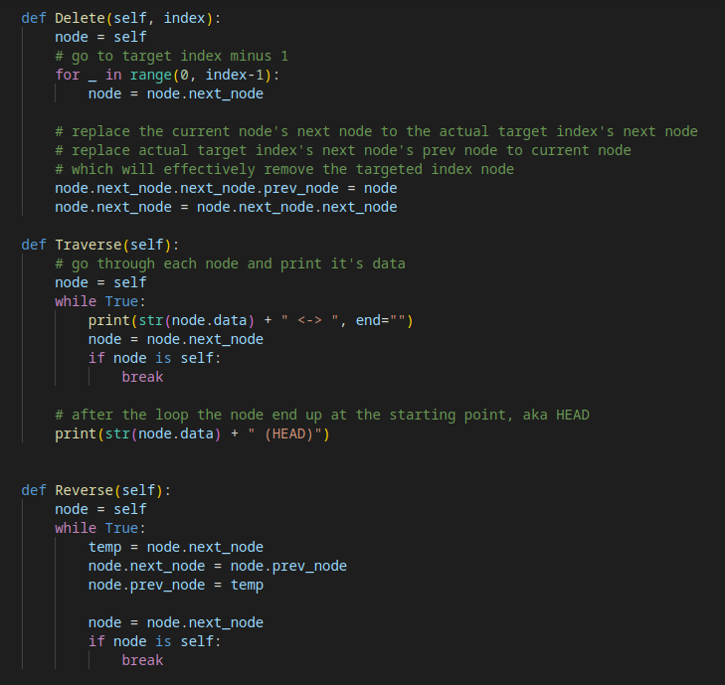
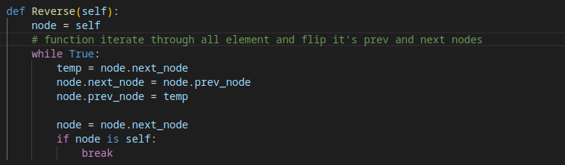

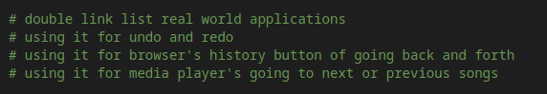

List out 3 real time usage of Doubly Linked List as comments in the program.
Note:
- Choose appropriate inputs for the above functions
- You can refer any source but try to follow the algorithm described in the lecture-4 video (Feb 19th class)
- Write the algorithm for each function as comments in the program
- Test the class’s function with an example.
- Attach screenshots of the program and results

